# Current Activities

Over the last few weeks we have been spending much of our regular Thursdays sorting through the various back office rooms, some of which have been undisturbed for years. We were able to dispose of a quantity of flat screen PC monitors and other hardware, where we already have at least a quantity of two. Another room full of posters, pictures, photographs and other miscellaneous items has also been cleared and tidied. There is much still to do, but we do have more storage space now for hardware that has otherwise been living on the floor.

### Complementary Bletchley Park Exhibition

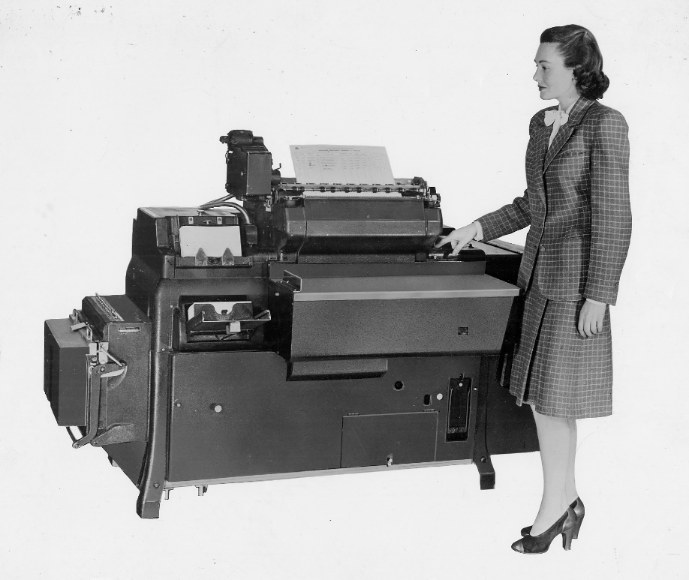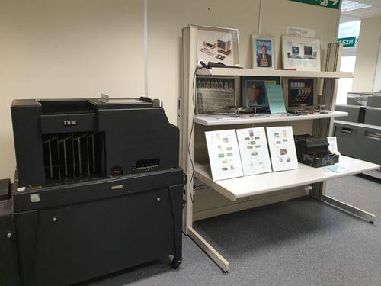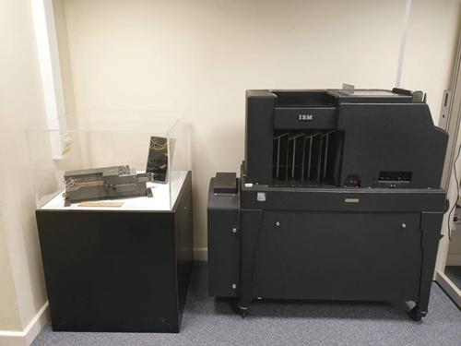With the successful launch of Bletchley Parks’ new exhibition “The Intelligence Factory” incorporating our 080 card sorter and a hand punch, we are in the process of preparing a ‘complimentary’ display based around a 077 card collator and 416 tabulator.

Many 405 tabulators, outwardly very similar to our 416, were used in Bletchley Park, as well as 077 tabulators, other ‘big iron’ card punch machines and a multitude of card punches.

*Top Left – Hursley Hand Punch & 077*

*Top Right – 077 and information boards*

*Bottom Left – Bletchley Park photo 405*

The Autumn edition of the Bletchley Park magazine, Ultra, includes an article co-authored by Dr Thomas Cheetham of Bletchley Park and Peter Coghlan one of our IBM Hursley Museum curators, which describes how Hollerith and IBM’s punch card technology, dating back to Victorian times became a vital part of Britain’s codebreaking machine. Alongside an overview of the processes and unique innovations needed to break down message data into usable information, the article also includes insights from some of the machine operators and analysts who worked tirelessly to punch cards, organise data flows and feed the ever-hungry machines.

### Bristol Office

The IBM Bristol office is closing and a number of artefacts loaned to them some time ago have been returned to Hursley.

### Law Society

The High Court in London is celebrating 150 years of the Technology and Construction Court. They have asked us to lend them a server and green screen terminal, or an early PC, for an exhibition to mark the occasion. We have persuaded one of our early IBM PC boxes back into life. We also have a couple of small AS/400 machines that were in working order, although a bit on the heavy side for moving around.

### Photo Archive

The photo archive of IBM hardware continues to grow, and a couple of ‘unidentifieds’ have been identified from photos found during our clearout. Also included are some photos taken at the opening of the new Bletchley Park exhibition, some Customer Engineering reference material and some miscellaneous documentation including all of the Hursley CCS reports. <http://igonta.net/hursley/index.asp> .